

**MINI PROJECT TITLE**

IMPLEMENTATION OF QUIZ USING JAVA



D. Sampath Reddy (9920004324)

A. Sameer Reddy (9920004303)

C. Vamsi Krishna Reddy (9920004339)



II CSE- G



Dr . Surya Mam

**KALASALINGAM ACADEMY OF RESEARCH AND**

**EDUCATION (DEEMED TO BE UNIVERSITY**

***KRISHNANKOIL 626 126***

***2020 – 2021***

### BONAFIDE CERTIFICATE

Certified that this project report **“**IMPLEMENTATION OF QUIZ USING JAVA**”** is the bonafide work of **D. Sampath Reddy(9920004324) A. Sameer Reddy (9920004303) C. Vamsi Krishna Reddy (9920004339)** who carried out the project work under my supervision.

**Supervisor Head of the Department**

**Dr. S.Surya Mr. Francis Saviour**

**Department of Computer science Department of Computer Science and Engineering and Engineering**

Submitted for the Project Viva-voice examination held on ………………….

**Dr .S.Surya**

**Internal Examiner External Examiner**

## 

## **ACKNOWLEDGEMENT**

“*Gratitude is the fairest blossom which springs from the soul*”

Feeling gratitude and not expressing it is like wrapping a present and not giving it. We take this opportunity to convey our heartfelt gratitude to each one who has supported us in every way or the other during our project.

His project was undertaken with the guidance, cooperation, and assistance of distinguished persons cited below who have contributed towards the successful completion of this project, we would like to express our thanks to the founder of our **Institution Ilaya Vallal Dr. K. Sridharan, Chancellor of Kalasalingam Academy of Research and Education** for providing us the necessary infrastructure and support to complete our project successfully.

We are extremely thankful and indebted to **Dr. S. Shasi Anand, Vice President of Kalasalingam Academy of Research and Education** who has given us the facilities to do our project successfully.

We are extremely thankful and indebted to **Dr. R. Nagaraj, Vice-Chancellor of Kalasalingam Academy of Research and Education** who has given us the facilities to do our project successfully.

We are extremely thankful and indebted to **Dr. V. Vasudevan, Registrar of Kalasalingam Academy of Research and Education** who has given us the facilities to do our project successfully. We are extremely thankful and indebted to **Francis Devraj, Head of the Department of Computer Science and Engineering** who has given us the facilities to do our project successfully.

We are much obliged to **Dr. S. Surya**, who is our project guide, for her support and encouragement by giving constructive criticism during the project period.

We wish to express our thanks and gratitude to our family and beloved ones and staff members of **DEPARTMENT OF COMPUTER SCIENCE AND ENGINEERING** for having helped us so generously with their valuable and constructive suggestions to improve the project and provide steady support.

**TABLE OF CONTENT**

**S.NO CONTENT PAGE-NO**

1. Introduction 5

2. Features 5

3. Architectural Design 6

4. Modules 7

5. Software Used 8

6. Coding 9

7. Screenshots 25

8. Conclusion 28

**INTRODUCTION**

Instead of the regular pen-paper examinations held by various institutions, one can make use of the Quiz Portal. Quiz Portal makes education fun and easier. This project is implemented using the Java language on the JAVA NetBeans IDE platform. The Online Quiz is a sort of web application for the students to emerge for an online examination efficiently and there is no failure of time to verify the paper. The main intend of the Online Quiz is to successfully approximate the applicant entirely via a computerized structure which besides preserving time, offers swifter outcomes. Normally, pupils are provided with paper, pen, etc for taking the examination but the Online Quiz does not necessitate all these.

This project aims to store the students’ data, measure the marks earned by each student and collect the names of the best students to be chosen for the next round. The Questionnaire program is used to administer a quiz for school or college pupils, or this software can also be used by the organization in the recruiting process.

The Quiz Portal is an application that helps in effectively taking tests and there is no wastage of time for checking the paper. The main objective of this project is to efficiently evaluate the candidate’s performance thoroughly through a completely automated system that not only saves a lot of precious time but also generates the result way quicker than the manual system. For students, the biggest advantage is that they get to give papers according to their convenience and time and the wastage of materials like pens, paper, etc is thoroughly reduced. There is no requirement for the presence of an invigilator during the exam sessions.

**FEATURES**

Taking online quizzes makes it possible to have a large number of participants. It could be up to several 1000 participants (and even more!). It doesn’t matter at what kind of location they take the online quiz as long as they are connected to the Internet. It is significantly more easy to randomize your question with just one click than to do it all manually. Randomizing questions and even answers to those questions is not a lot of work to do with online quizzes. Besides the advantage of time-saving, it also helps prevent students from cheating.

The creator can Set a Timer for the whole quiz or set a timer per question. This is possible to do with written quizzes but is very time-consuming for the instructor. Plus it’s almost impossible to do with a huge amount of participants.

**ARCHITECTURAL DESIGN**

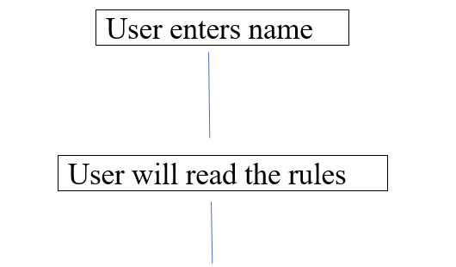

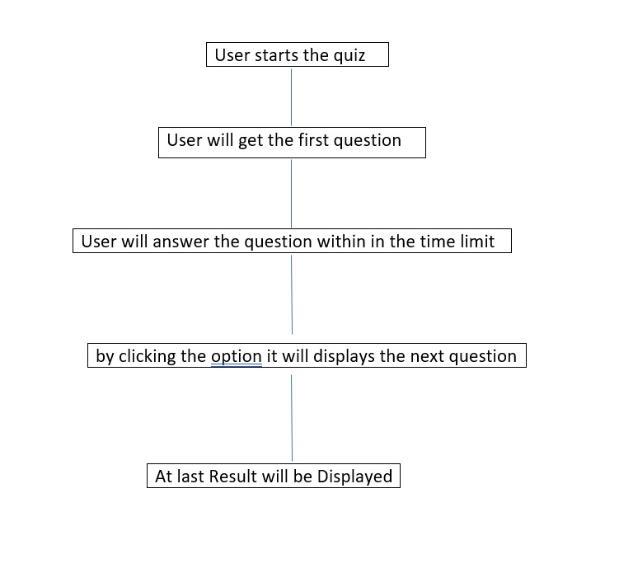

**MODULES**

* **Account Setting**: The Admin includes the questions and edits the questions for others so that they can read the questions and options in their system.
* **Registration**: The user who answers the quiz should type his/her name to get their result, 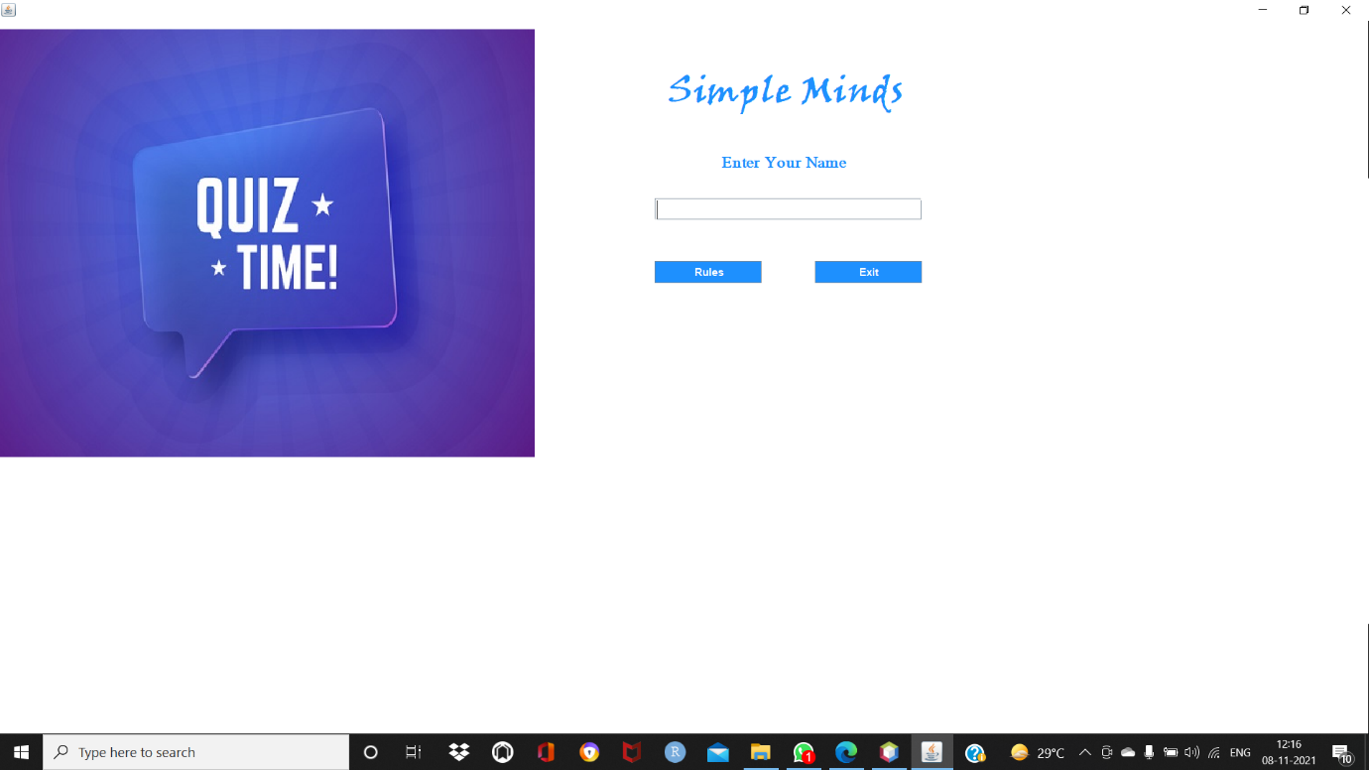
* **Quiz**: As soon as the user chooses the quiz menu strip, the questions with four choices will be shown. The user must type any of the options and click on the next option. Otherwise, there is a timer option after the time up the next question will come as shown in the below fig

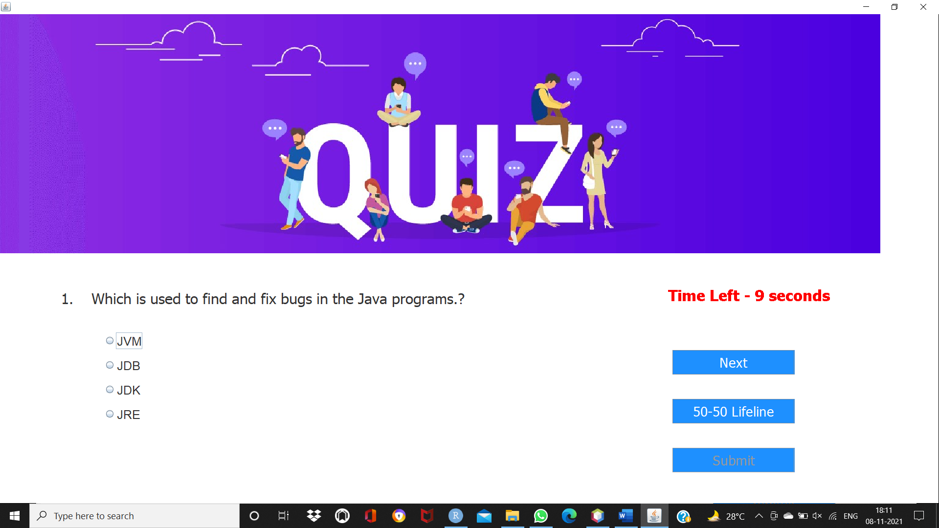

* **Result**: This displays the outcome of all the users who replied in descending order. Just the Admin has the right to display it as shown in the below fig.

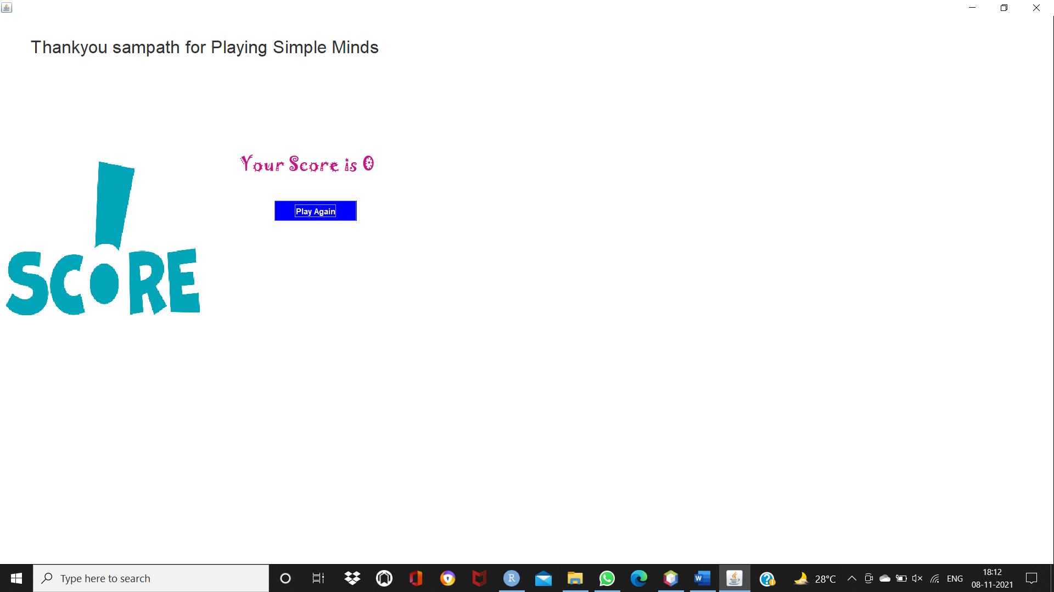

.

**SOFTWARES USED**

🡪 JAVA

🡪Netbeans IDE platform

**CODING**

// ---------------------------- Quiz ----------------------------

package simply. minds;

import javax.swing.*;

import java.awt.*;

import java.awt.event.*;

public class Quiz extends JFrame implements ActionListener{

JButton next, submit, lifeline;

public static int count = 0;

public static int timer = 15;

public static int ans_given = 0;

public static int score = 0;

JLabel qno, question;

String q[][] = new String[10][5];

String pa[][] = new String[10][1];

String qa[][] = new String[10][2];

JRadioButton opt1, opt2, opt3, opt4;

ButtonGroup options;

String username;

Quiz(String username){

this.username = username;

setBounds(250, 50, 1440, 950);

getContentPane().setBackground(Color.WHITE);

setLayout(null);

ImageIcon i1 = new ImageIcon(ClassLoader.getSystemResource("simple/minds/icons/quiz.jpg"));

JLabel l1 = new JLabel(i1);

l1.setBounds(0, 0, 1440, 392);

add(l1);

qno = new JLabel("");

qno.setFont(new Font("Tahoma", Font.PLAIN, 24));

qno.setBounds(100, 450, 50, 30);

add(qno);

question = new JLabel("");

question.setFont(new Font("Tahoma", Font.PLAIN, 24));

question.setBounds(150, 450, 900, 30);

add(question);

q[0][0] = "Which is used to find and fix bugs in the Java programs.?";

q[0][1] = "JVM";

q[0][2] = "JDB";

q[0][3] = "JDK";

q[0][4] = "JRE";

q[1][0] = "What is the return type of the hashCode() method in the Object class?";

q[1][1] = "int";

q[1][2] = "Object";

q[1][3] = "long";

q[1][4] = "void";

q[2][0] = "Which package contains the Random class?";

q[2][1] = "java.util package";

q[2][2] = "java.lang package";

q[2][3] = "java.awt package";

q[2][4] = "java.io package";

q[3][0] = "An interface with no fields or methods is known as?";

q[3][1] = "Runnable Interface";

q[3][2] = "Abstract Interface";

q[3][3] = "Marker Interface";

q[3][4] = "CharSequence Interface";

q[4][0] = "In which memory a String is stored, when we create a string using new operator?";

q[4][1] = "Stack";

q[4][2] = "String memory";

q[4][3] = "Random storage space";

q[4][4] = "Heap memory";

q[5][0] = "Which of the following is a marker interface?";

q[5][1] = "Runnable interface";

q[5][2] = "Remote interface";

q[5][3] = "Readable interface";

q[5][4] = "Result interface";

q[6][0] = "Which keyword is used for accessing the features of a package?";

q[6][1] = "import";

q[6][2] = "package";

q[6][3] = "extends";

q[6][4] = "export";

q[7][0] = "In java, jar stands for?";

q[7][1] = "Java Archive Runner";

q[7][2] = "Java Archive";

q[7][3] = "Java Application Resource";

q[7][4] = "Java Application Runner";

q[8][0] = "Which of the following is a mutable class in java?";

q[8][1] = "java.lang.StringBuilder";

q[8][2] = "java.lang.Short";

q[8][3] = "java.lang.Byte";

q[8][4] = "java.lang.String";

q[9][0] = "Which of the following option leads to the portability and security of Java?";

q[9][1] = "Bytecode is executed by JVM";

q[9][2] = "The applet makes the Java code secure and portable";

q[9][3] = "Use of exception handling";

q[9][4] = "Dynamic binding between objects";

qa[0][1] = "JDB";

qa[1][1] = "int";

qa[2][1] = "java.util package";

qa[3][1] = "Marker Interface";

qa[4][1] = "Heap memory";

qa[5][1] = "Remote interface";

qa[6][1] = "import";

qa[7][1] = "Java Archive";

qa[8][1] = "java.lang.StringBuilder";

qa[9][1] = "Bytecode is executed by JVM";

opt1 = new JRadioButton("");

opt1.setBounds(170, 520, 700, 30);

opt1.setFont(new Font("Dialog", Font.PLAIN, 20));

opt1.setBackground(Color.WHITE);

add(opt1);

opt2 = new JRadioButton("");

opt2.setBounds(170, 560, 700, 30);

opt2.setFont(new Font("Dialog", Font.PLAIN, 20));

opt2.setBackground(Color.WHITE);

add(opt2);

opt3 = new JRadioButton("");

opt3.setBounds(170, 600, 700, 30);

opt3.setFont(new Font("Dialog", Font.PLAIN, 20));

opt3.setBackground(Color.WHITE);

add(opt3);

opt4 = new JRadioButton("");

opt4.setBounds(170, 640, 700, 30);

opt4.setFont(new Font("Dialog", Font.PLAIN, 20));

opt4.setBackground(Color.WHITE);

add(opt4);

options = new ButtonGroup();

options.add(opt1);

options.add(opt2);

options.add(opt3);

options.add(opt4);

next = new JButton("Next");

next.setFont(new Font("Tahoma", Font.PLAIN, 22));

next.setBackground(new Color(30, 144, 255));

next.setForeground(Color.WHITE);

next.addActionListener(this);

next.setBounds(1100, 550, 200, 40);

add(next);

lifeline = new JButton("50-50 Lifeline");

lifeline.setFont(new Font("Tahoma", Font.PLAIN, 22));

lifeline.setBackground(new Color(30, 144, 255));

lifeline.setForeground(Color.WHITE);

lifeline.setBounds(1100, 630, 200, 40);

lifeline.addActionListener(this);

add(lifeline);

submit = new JButton("Submit");

submit.setFont(new Font("Tahoma", Font.PLAIN, 22));

submit.setEnabled(false);

submit.setBackground(new Color(30, 144, 255));

submit.setForeground(Color.WHITE);

submit.addActionListener(this);

submit.setBounds(1100, 710, 200, 40);

add(submit);

start(0);

}

public void actionPerformed(ActionEvent ae){

if(ae.getSource() == next){

repaint();

opt1.setEnabled(true);

opt2.setEnabled(true);

opt3.setEnabled(true);

opt4.setEnabled(true);

ans_given = 1;

if(options.getSelection() == null){

pa[count][0] = "";

}else {

pa[count][0] = options.getSelection().getActionCommand();

}

if(count == 8){

next.setEnabled(false);

submit.setEnabled(true);

}

count++;

start(count);

}else if(ae.getSource() == submit){

ans_given = 1;

if(options.getSelection() == null){

pa[count][0] = "";

}else {

pa[count][0] = options.getSelection().getActionCommand();

}

for(int i =0 ; i < pa.length ; i++){

if(pa[i][0].equals(qa[i][1])){

score+=10;

}else{

score+=0;

}

}

this.setVisible(false);

new Score(username, score).setVisible(true);

}else if(ae.getSource() == lifeline){

if(count == 2 || count == 4 || count == 6 || count == 8 || count == 9){

opt2.setEnabled(false);

opt3.setEnabled(false);

}else {

opt1.setEnabled(false);

opt4.setEnabled(false);

}

lifeline.setEnabled(false);

}

}

public void paint(Graphics g){

super.paint(g);

String time = "Time Left - " + timer + " seconds"; // 15

g.setColor(Color.RED);

g.setFont(new Font("Tahoma", Font.BOLD, 25));

if(timer > 0) {

g.drawString(time, 1100, 500);

}else {

g.drawString("Times Up!!", 1100, 500);

}

timer--; // 14

try{

Thread.sleep(1000);

repaint();

}catch(Exception e){

e.printStackTrace();

}

if(ans_given == 1){

ans_given = 0;

timer = 15;

}else if(timer < 0){

timer = 15;

opt1.setEnabled(true);

opt2.setEnabled(true);

opt3.setEnabled(true);

opt4.setEnabled(true);

if(count == 8){

next.setEnabled(false);

submit.setEnabled(true);

}

if(count == 9){

if(options.getSelection() == null){

pa[count][0] = "";

}else {

pa[count][0] = options.getSelection().getActionCommand();

}

for(int i =0 ; i < pa.length ; i++){

if(pa[i][0].equals(qa[i][1])){

score+=10;

}else{

score+=0;

}

}

this.setVisible(false);

new Score(username, score).setVisible(true);

}else{

if(options.getSelection() == null){

pa[count][0] = "";

}else {

pa[count][0] = options.getSelection().getActionCommand();

}

count++;

start(count);

}

}

}

public void start(int count){

qno.setText("" + (count + 1) + ". ");

question.setText(q[count][0]);

opt1.setLabel(q[count][1]);

opt1.setActionCommand(q[count][1]);

opt2.setLabel(q[count][2]);

opt2.setActionCommand(q[count][2]);

opt3.setLabel(q[count][3]);

opt3.setActionCommand(q[count][3]);

opt4.setLabel(q[count][4]);

opt4.setActionCommand(q[count][4]);

options.clearSelection();

}

public static void main(String[] args){

new Quiz("").setVisible(true);

}

}

//RULES

package simple.minds;

import javax.swing.*;

import java.awt.*;

import java.awt.event.*;

public class Rules extends JFrame implements ActionListener{

JButton b1, b2;

String username;

Rules(String username){

this.username = username;

setBounds(600, 200, 800, 650);

getContentPane().setBackground(Color.WHITE);

setLayout(null);

JLabel l1 = new JLabel("Welcome " + username + " to Simple Minds");

l1.setForeground(new Color(30, 144, 255));

l1.setFont(new Font("Viner Hand ITC", Font.BOLD, 28));

l1.setBounds(50, 20, 700, 30);

add(l1);

JLabel l2 = new JLabel("");

l2.setFont(new Font("Tahoma", Font.PLAIN, 16));

l2.setBounds(20, 90, 600, 350);

l2.setText(

"<html>"+

"1. You are trained to be a programmer and not a storyteller, answer point to point" + "<br><br>" +

"2. Do not unnecessarily smile at the person sitting next to you, they may also not know the answer" + "<br><br>" +

"3. You may have a lot of options in life but here all the questions are compulsory" + "<br><br>" +

"4. Crying is allowed but please do so quietly." + "<br><br>" +

"5. Only a fool asks and a wise answers (Be wise, not otherwise)" + "<br><br>" +

"6. Do not get nervous if your friend is answering more questions, may be he/she is doing Jai Mata Di" + "<br><br>" +

"7. Brace yourself, this paper is not for the faint hearted" + "<br><br>" +

"8. May you know more than what John Snow knows, Good Luck" + "<br><br>" +

"<html>"

);

add(l2);

b1 = new JButton("Back");

b1.setBounds(250, 500, 100, 30);

b1.setBackground(new Color(30, 144, 255));

b1.setForeground(Color.WHITE);

b1.addActionListener(this);

add(b1);

b2 = new JButton("Start");

b2.setBounds(400, 500, 100, 30);

b2.setBackground(new Color(30, 144, 255));

b2.setForeground(Color.WHITE);

b2.addActionListener(this);

add(b2);

setVisible(true);

}

public void actionPerformed(ActionEvent ae){

if(ae.getSource() == b1){

this.setVisible(false);

new SimpleMinds().setVisible(true);

}else if(ae.getSource() == b2){

this.setVisible(false);

new Quiz(username).setVisible(true);

}

}

public static void main(String[] args){

new Rules("");

}

}

//SCORE

package simple.minds;

import javax.swing.*;

import java.awt.*;

import java.awt.event.*;

public class Score extends JFrame implements ActionListener{

Score(String username, int score){

setBounds(600, 150, 750, 550);

getContentPane().setBackground(Color.WHITE);

setLayout(null);

ImageIcon i1 = new ImageIcon(ClassLoader.getSystemResource("simple/minds/icons/score.png"));

Image i2 = i1.getImage().getScaledInstance(300, 250, Image.SCALE_DEFAULT);

ImageIcon i3 = new ImageIcon(i2);

JLabel l1 = new JLabel(i3);

l1.setBounds(0, 200, 300, 250);

add(l1);

JLabel l2 = new JLabel("Thankyou " + username + " for Playing Simple Minds");

l2.setBounds(45, 30, 700, 30);

l2.setFont(new Font("RALEWAY", Font.PLAIN, 26));

add(l2);

JLabel l3 = new JLabel("Your Score is " + score);

l3.setBounds(350, 200, 300, 30);

l3.setFont(new Font("Jokerman", Font.PLAIN, 26));

l3.setForeground(new Color(199, 21, 133));

add(l3);

JButton b1 = new JButton("Play Again");

b1.setBackground(Color.BLUE);

b1.setForeground(Color.WHITE);

b1.addActionListener(this);

b1.setBounds(400, 270, 120, 30);

add(b1);

}

public void actionPerformed(ActionEvent ae){

this.setVisible(false);

new SimpleMinds().setVisible(true);

}

public static void main(String[] args){

new Score("", 0).setVisible(true);

}

}

//----------------

package simple.minds;

import javax.swing.*;

import java.awt.*;

import java.awt.event.*;

public class SimpleMinds extends JFrame implements ActionListener{

JButton b1, b2;

JTextField t1;

SimpleMinds(){

setBounds(400, 200, 1200, 500); // dleft, //dup // length, height ///////

getContentPane().setBackground(Color.WHITE);

setLayout(null);

ImageIcon i1 = new ImageIcon(ClassLoader.getSystemResource("simple/minds/icons/login.jpeg"));

JLabel l1 = new JLabel(i1);

l1.setBounds(0, 0, 600, 500);

add(l1);

JLabel l2 = new JLabel("Simple Minds");

l2.setFont(new Font("Viner Hand ITC", Font.BOLD, 40));

l2.setForeground(new Color(30, 144, 254));

l2.setBounds(750, 60, 300, 45);

add(l2);

JLabel l3 = new JLabel("Enter Your Name");

l3.setFont(new Font("Mongolian Baiti", Font.BOLD, 18));

l3.setForeground(new Color(30, 144, 254));

l3.setBounds(810, 150, 300, 20);

add(l3);

t1 = new JTextField();

t1.setBounds(735, 200, 300, 25);

t1.setFont(new Font("Times New Roman", Font.BOLD, 20));

add(t1);

b1 = new JButton("Rules");

b1.setBounds(735, 270, 120, 25);

b1.setBackground(new Color(30, 144, 254));

b1.setForeground(Color.WHITE);

b1.addActionListener(this);

add(b1);

b2 = new JButton("Exit");

b2.setBounds(915, 270, 120, 25);

b2.setBackground(new Color(30, 144, 254));

b2.setForeground(Color.WHITE);

b2.addActionListener(this);

add(b2);

setVisible(true);

}

public void actionPerformed(ActionEvent ae){

if(ae.getSource() == b1){

String name = t1.getText();

this.setVisible(false);

new Rules(name);

}else{

System.exit(0);

}

}

public static void main(String[] args) {

new SimpleMinds();

}

}

**SCREENSHOTS**:

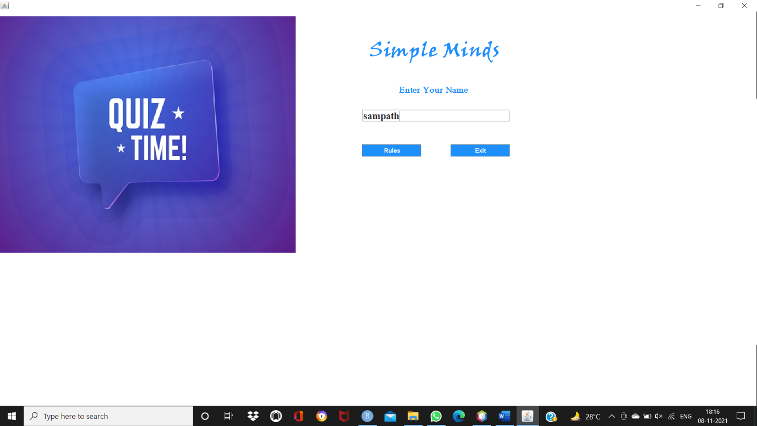

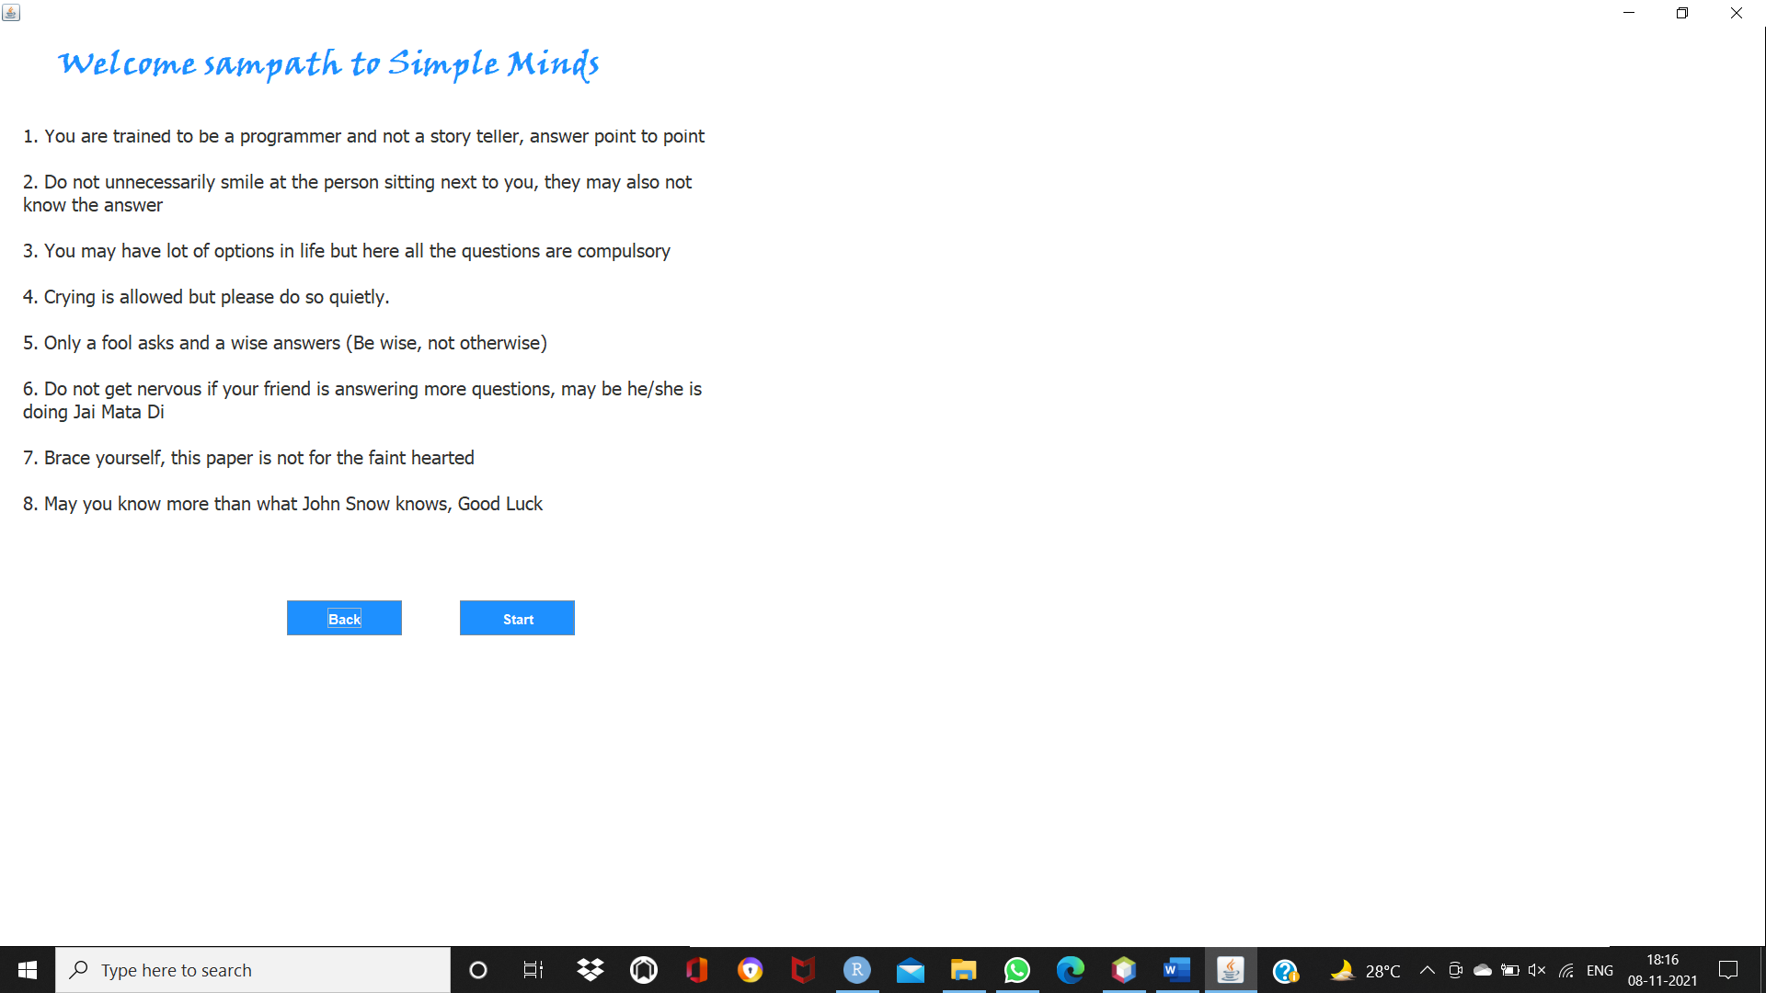

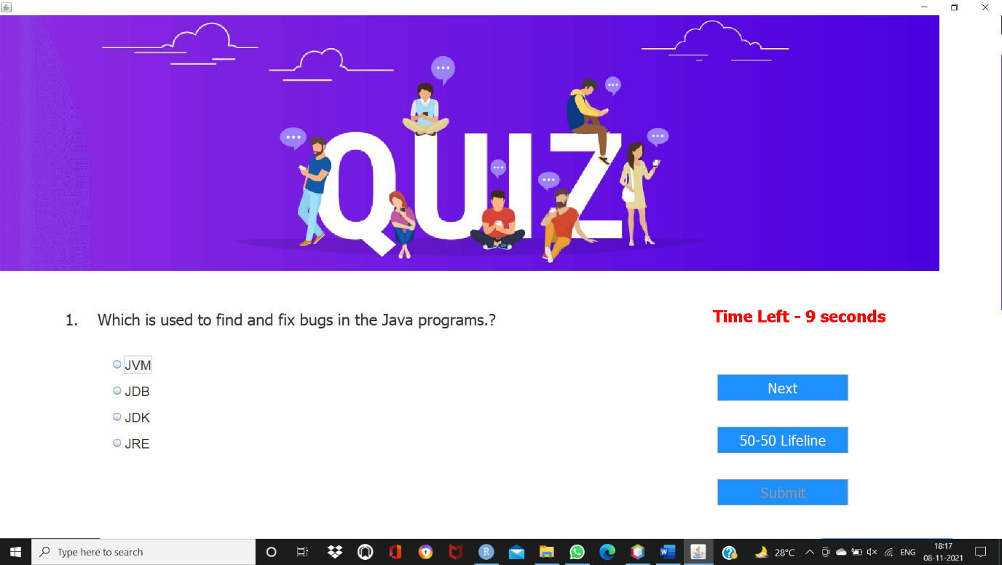

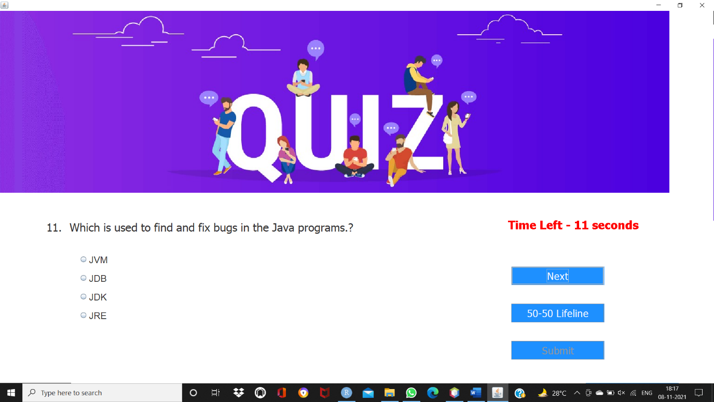



**CONCLUSION**:

“QUIZ” software developed for a school or to a college has been designed for time reduction taken for conducting a quiz, for calculating the marks, for shortlisting the student’s name, hence increasing the efficiency. It is designed to replace existing paperwork and correction manually.

For students, they give papers according to their convenience and time and there is no need of using extra things like paper, pen, etc. This can be used in educational institutions as well as incorporate the world. Can be used anywhere at any time as it is a web-based application(user location doesn’t matter). No restriction that the examiner has to be present when the candidate takes the test.

Thank you